
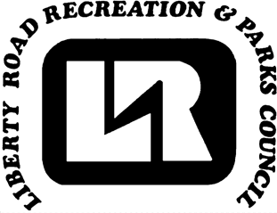
Randallstown Track Club Presents
INDOOR TRACK PROGRAM

Sponsored by
Liberty Road Recreation and Parks Council

NO EXPERIENCE NECESSARY

RANDALLSTOWN TRACK CLUB INDOOR 2025 TRACK PROGRAM
FOR: BOYS & GIRLS AGE 6-17 YEARS OLD.

REGISTRATION: From Oct, 13 2025 To Dec 31, 2025 $150 NO REFUNDS
Registration online only at
https://libertyroadmd.myrec.com/info/activities/program_details.aspx?ProgramID=29900
then select LRRPC - Track & Field

PROGRAM STARTS: FROM Thursday Nov 13 2025 - Saturday, March 14 2026

PRACTICES: Randallstown Community Center
Address; 3505 Resource Dr, Randallstown, MD 21133
November 13 – March 14 Tuesday & Thursday 6pm to 8pm

Information Session: Tuesday November 6, 2025 at 645pm at the track

MEETS: ALL INDOOR MEETS ARE ON THE WEEKENDS, APPROXIMATELY 7 (Seven) HOURS. (Not including weekly meet fees)
REGISTRATION: $150 PER PARTICIPANT (Registration only) NO REFUNDS

Head Coach – Kateri Bowie
Assistant Coach - Mercedes Rogers
Advisor - Kelvin Taylor
Chairperson – Ayanna Barrows email: Randallstowntrack@gmail.com
FOR MORE INFORMATION, CALL LIBERTY ROAD RECREATION OFFICE 410-887-0700 BETWEEN THE HOURS OF 9:00 AM AND 3:00 PM WEEKDAYS.

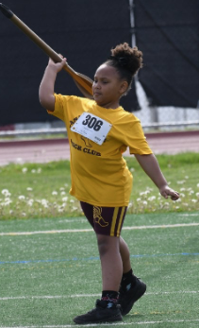

These materials are neither sponsored by nor endorsed by the Board of Education of Baltimore County, the Superintendent, or this school office. This program is designed to provide a healthy and enjoyable leisure experience for your child. However, this is not a licensed childcare program and is not designed to provide childcare. Therefore, parents are encouraged to discuss attendance expectations with their children. Department staff and volunteers cannot detain youth wishing to leave at any time. Should you require special accommodations (American sign language interpreter, large print, etc.) please give us as much notice as possible by calling the Therapeutic Office at 410-887-5370. TTY users call via Maryland Relay 711

