Liberty Road

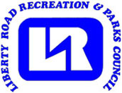

Junior League Wrestling Team

At Milford Mill Academy

Boys & Girls 4 - 15

Registration: Online registration opens Oct 1st [WWW.LRRPC.ORG](http://WWW.LRRPC.ORG)

First practice Monday, November 1, 2025

Practices are every Monday, Wednesday and Thursday night at Milford Mill Academy 6pm – 8pm door #20.

Milford Mill Academy

3800 Washington Ave

Baltimore, Maryland 21244

(Come to the Locker room doors - around back next to the

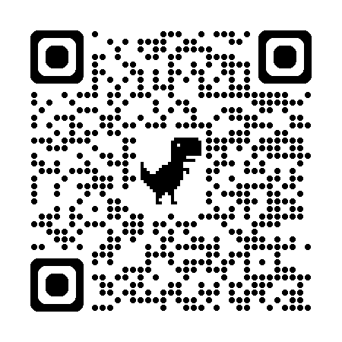

tennis courts door #20.)

Cost: $85 per Wrestler

The season goes from November 1st to April 1st.

Should you require special accommodation (i.e. sign language interpreter, large print, etc.). Please give as much notice as possible by calling the therapeutic office at (410) 887-5370 (voice or (410) 887-5319 (TT/Deaf)